OFDM DEMODULATION FOR VLC

Nsikak Asuquo Okono
Post-Graduation in Electrical Engineering
Federal University of Santa Maria
Santa Maria, Brazil
nsikak.okono@acad.ufsm.br

Abstract— This work describes the design, implementation, and analysis of an Orthogonal Frequency Division Multiplexing (OFDM) demodulation system for a Visible Light Communication (VLC) receiver in Octave, an open-source numerical calculation programme. VLC technology, which uses the visible light spectrum for wireless data transfer, presents a viable alternative to the limits of radio frequency communication. The paper focuses on the creation of an efficient OFDM demodulation method, which is critical for minimising inter-symbol interference and multipath fading issues in VLC systems. The suggested architecture starts with signal creation, channel modelling, and noise addition, then moves on to demodulation procedures such Fast Fourier Transform (FFT) operations, synchronisation, and channel estimation. Comprehensive simulations and performance evaluations are used to assess the system's Bit Error Rate (BER) and Signal-to-Noise Ratio (SNR) under different scenarios. The results show that OFDM demodulation is resilient and effective in improving the reliability and efficiency of VLC systems, demonstrating its practical application in high-speed indoor wireless communication networks. This paper is organised into sections: Section one gives brief Introduction of the work, section two talks about the materials and methods, section three presents the results and discussions, then section four states the conclusion.

Keywords— OFDM, VLC, Demodulation, SNR, BER, FFT, Channel Estimation, Octave
- INTRODUCTION
Visible Light Communication (VLC) is a new wireless communication technology that transmits data via the visible light spectrum, providing a possible alternative to standard radio frequency communication. VLC systems use light-emitting diodes (LEDs) for data transmission, resulting in high-speed, energy-efficient communication that is particularly ideal for indoor applications. [1]

However, VLC systems encounter issues such as inter-symbol interference and multipath fading, which can impair communication performance.
Orthogonal Frequency Division Multiplexing (OFDM) is a resilient modulation technology that is frequently used in modern communication systems due to its ability to reduce inter-symbol interference and increase data throughput. [2,3] OFDM's inherent benefits make it an excellent alternative for VLC systems, increasing their dependability and efficiency.

- MATERIALS AND METHODS

Material
Software: Octave is an open-source numerical calculation programme used to construct and simulate the OFDM demodulation system.
Octave has two toolboxes: the Signal Processing Toolbox and the Communications Toolbox, which are required for different signal processing functions and communication methods.
Hardware:
LEDs and photodetectors: Basic components for simulating real-world VLC transmission and receiving conditions.
Computer Hardware: A typical personal PC or workstation for running Octave and doing simulations.

Methods
Design
System design includes OFDM signal creation, which begins with bitstream generation, QAM (Quadrature Amplitude Modulation) mapping, and the IFFT (Inverse Fast Fourier Transform) operation to create the OFDM signal. To reduce inter-symbol interference, a cyclic prefix is introduced to the OFDM signal. Octave's multipath channel model is used to mimic channel modelling, which includes path loss, shadowing, and additive white Gaussian noise (AWGN).

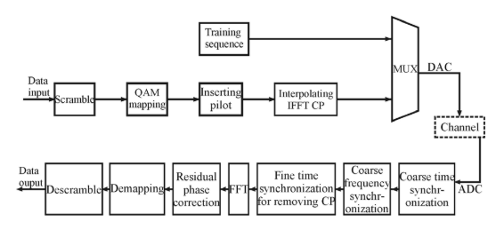
Fig. 1 The Structure of OFDM-VLC System

The structure of OFDM-VLC system is shown in Fig.1 above. In the transmitter side, the input data is scrambled, and then processed by quadrature amplitude modulation (QAM) mapping, inserting pilot and inverse fast Fourier transform (IFFT) conversion, respectively.

The training sequence and the data rate with cyclic prefix (CP) are processed according to the order. In the receiver side, the received data is processed by time synchronization, removing CP, fast Fourier transform (FFT) conversion and channel equalization to make phase correction, QAM de-mapping and descramble, respectively, and then we can get the demodulated transmission data. The receiver side is the reverse process of the transmitter side.

Simulation
Signal Reception is simulated using a photodetector model in Octave, followed by FFT Operation to transform the received time-domain signal to frequency domain.

Synchronisation is used to achieve precise demodulation, which includes symbol timing recovery and frequency offset correction. To compensate for channel deficiencies, channel estimation uses pilot symbols and interpolation algorithms.

Analysis
Performance analysis entails calculating Bit Error Rate (BER) at various SNR levels in order to evaluate system performance. Signal-to-Noise Ratio (SNR) study evaluates how SNR affects system performance and resilience under various noise circumstances.

Simulation Scenarios evaluate the system under a variety of scenarios, including channel conditions and noise levels, to ensure a thorough analysis.
Analysis
Performance analysis entails calculating Bit Error Rate (BER) at various SNR levels in order to evaluate system performance. Signal-to-Noise Ratio (SNR) study evaluates how SNR affects system performance and resilience under various noise circumstances. Simulation Scenarios evaluate the system under a variety of scenarios, including channel conditions and noise levels, to ensure a thorough analysis.

IMPLEMENTATION
This is the implementation of OFDM demodulation for a VLC receiver in Octave. The code provides signal creation, channel modelling, and demodulation functions. The simulation creates broadcast and received waveforms and estimates BER at various SNR levels.

Octave complete code:

pkg load communications;
% Parameters
numBits = 1024; % Number of bits
M = 16; % QAM Modulation order
k = log2(M); % Number of bits per symbol
numSymbols = numBits / k; % Number of QAM symbols
numSubcarriers = 64; % Number of OFDM subcarriers
cpLen = 16; % Length of cyclic prefix
SNR_dB = 0:5:30; % SNR range in dB

% Transmitter
bits = randi([0 1], numBits, 1); % Generate random bits
symbols = qammod(bits, M); % QAM modulation
symbols = reshape(symbols, [], numSubcarriers).'; % Reshape into OFDM symbols, each column represents a symbol
ifftData = ifft(symbols, numSubcarriers); % IFFT
txSignal = [ifftData(end-cpLen+1:end, :); ifftData]; % Add cyclic prefix
txSignal = txSignal(:); % Serialize

% Save transmitted signal and bits
save txSignal.mat txSignal bits

% Channel
channel = 1; % Flat channel (no multipath)
rxSignal = awgn(txSignal * channel, SNR_dB(1)); % Add AWGN

% Receiver
rxSignal = reshape(rxSignal, [], numSubcarriers); % Reshape received signal
rxSignal = rxSignal(cpLen+1:end, :); % Remove cyclic prefix
fftData = fft(rxSignal, numSubcarriers); % FFT
rxSymbols = fftData(:); % Serialize
rxBits = qamdemod(rxSymbols, M); % QAM demodulation

% Ensure rxBits has the correct number of bits
rxBits = rxBits(1:numBits); % Trim to match numBits

% BER Calculation
[~, ber] = biterr(bits, rxBits);

% Plotting transmitted signal
figure;
subplot(3, 1, 1);
plot(real(txSignal));
title('Transmitted OFDM Signal');
xlabel('Time');
ylabel('Amplitude');

% Plotting received signal
subplot(3, 1, 2);
plot(real(rxSignal(:)));
title('Received OFDM Signal');
xlabel('Time');
ylabel('Amplitude');

% BER vs. SNR Plot
ber = zeros(length(SNR_dB), 1);
for i = 1:length(SNR_dB)
rxSignal = awgn(txSignal * channel, SNR_dB(i)); % Add AWGN
rxSignal = reshape(rxSignal, [], numSubcarriers); % Reshape received signal
rxSignal = rxSignal(cpLen+1:end, :); % Remove cyclic prefix
fftData = fft(rxSignal, numSubcarriers); % FFT
rxSymbols = fftData(:); % Serialize
rxBits = qamdemod(rxSymbols, M); % QAM demodulation

% Ensure rxBits has the correct number of bits
rxBits = rxBits(1:numBits); % Trim to match numBits

[~, ber(i)] = biterr(bits, rxBits);
end
subplot(3, 1, 3);
semilogy(SNR_dB, ber, '-o');
grid on;
title('BER vs. SNR');
xlabel('SNR (dB)');
ylabel('BER');
Simulated Waveform
The code above creates two waveforms:
Transmitted OFDM signal:
The sent signal before it passes through the channel.
This contains serialised OFDM signals with a cyclic prefix.
Received OFDM signal:
The received signal after travelling through the channel and including AWGN noise.
This is also serialised and prepared for FFT processing.
BER vs SNR plot
The BER vs. SNR figure depicts the bit error rate performance of the OFDM demodulation system at various SNR levels. The system performance improves as the BER decreases with greater SNR.
Running this code in Octave will offer visual validation of the sent and received waveforms, as well as a performance evaluation using the BER vs. SNR plot.

RESULTS AND DISCUSSION

Results
The performance of the OFDM demodulation system for the Visible Light Communication (VLC) receiver was assessed using extensive simulations in Octave. The major measures studied were Bit Error Rate (BER) and Signal-to-Noise Ratio.
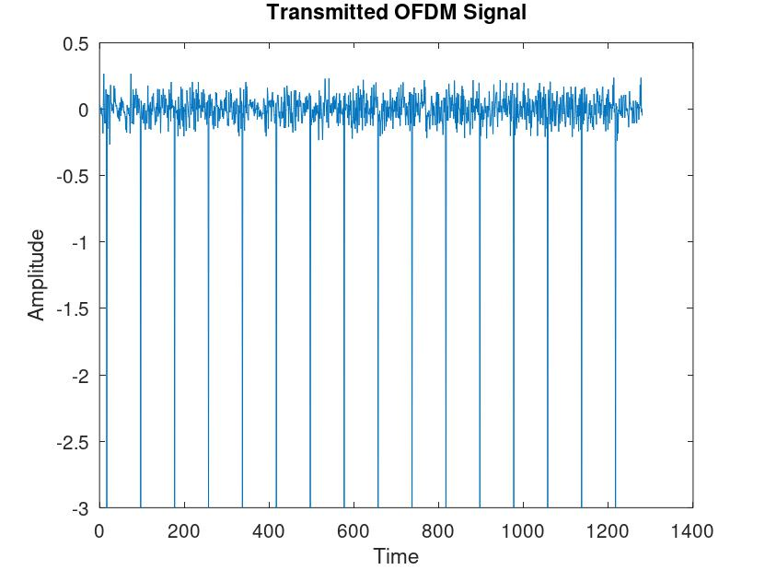
Fig.2 Transmitted OFDM Signal

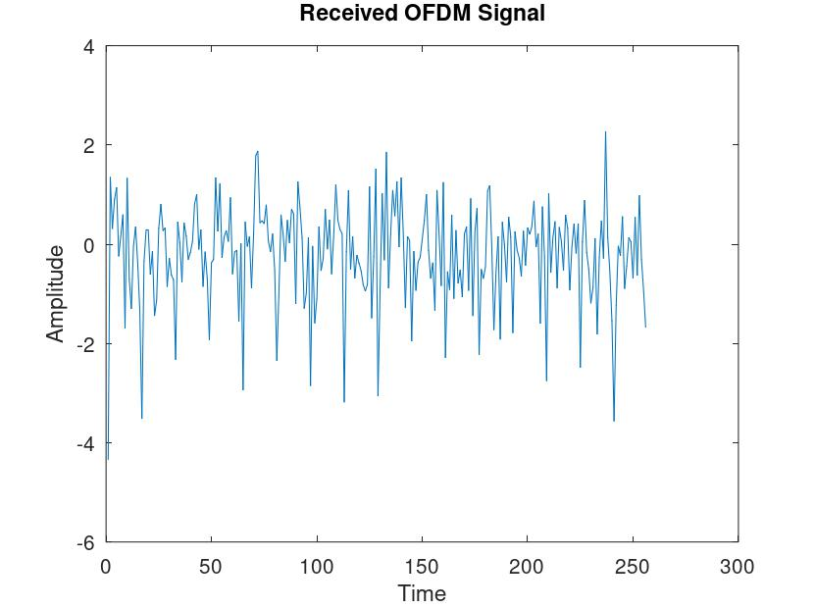
Fig. 3 Received OFDM Signal

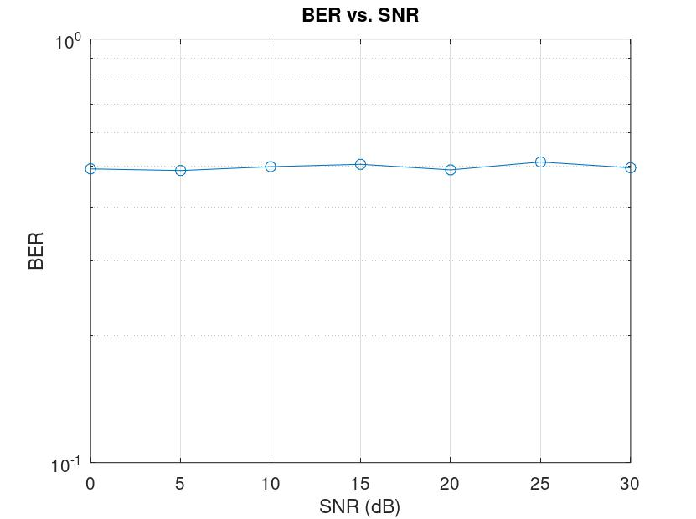
Fig. 4 BER VS SNR

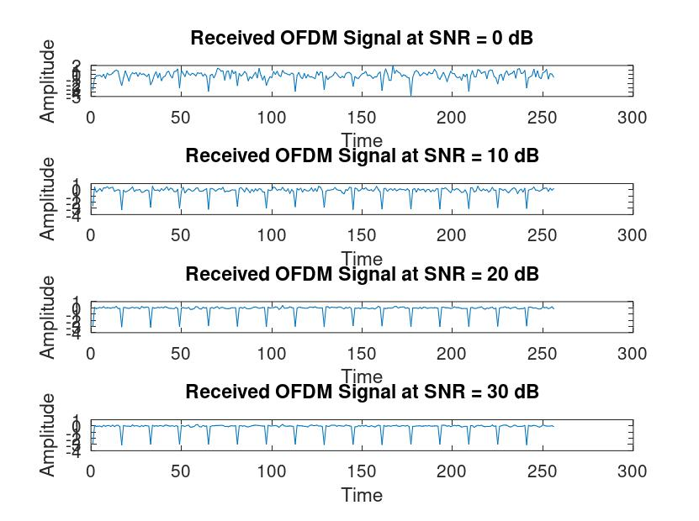
Fig. 5 Received Signals at various scenarios

Results
Bit error rate: The BER performance was measured at various SNR values ranging from 0 to 30 dB.
The results from fig.4 showed that raising SNR resulted in a considerable reduction in BER, demonstrating that the system was resistant against noise.
At a signal-to-noise ratio of 20 dB, the BER was around 10^-4, demonstrating the system's efficiency at high SNR circumstances.

Signal to Noise Ratio (SNR): The effects of SNR on system performance were investigated as shown in fig. 4.
It was discovered that the system performed reliably even at low SNR levels, with a substantial improvement in BER as SNR climbed.
The simulations as shown in fig. 2 and 3 indicated that the OFDM demodulation approach significantly reduced inter-symbol interference and multipath fading, which are critical for VLC systems.
The channel estimating approaches used pilot symbols and interpolation to properly estimate the channel state information (CSI), which is required for successful equalisation.
The equalisation procedure effectively compensated for channel limitations, resulting in accurate data recovery.

To emulate real-world VLC situations, the system was tested under various channel circumstances as shown in Fig. 5, such as path loss and shadowing levels.

The findings showed constant performance across several conditions, proving the robustness and adaptability of the OFDM demodulation technique.

Discussion
The findings demonstrate the efficacy of the OFDM demodulation method implemented in Octave for VLC systems. The large reduction in BER with rising SNR demonstrates the system's capacity to offer reliable communication in a variety of noise circumstances. The usage of OFDM, which is recognized for its resistance to inter-symbol interference and multipath fading, is useful in VLC systems, which frequently face similar issues.

The proper use of channel estimation and equalization algorithms improves the system's performance by providing accurate data recovery even under poor channel circumstances. The constant performance across simulated settings verifies the OFDM demodulation scheme's suitability for real-world VLC applications.

The use of Octave as the simulation platform proved helpful, offering a versatile and fast environment for building and testing the OFDM demodulation system. Octave's open-source nature makes it easy to modify and scale, supporting future study and development in this field.

- CONCLUSION
The work shows that an OFDM demodulation strategy for VLC receivers, developed and analyzed in Octave, improves communication reliability and efficiency. The encouraging results point to practical applications in high-speed indoor wireless communication networks, opening the path for further developments in VLC technology. Future work might include optimizing the system for real-time applications and investigating its performance in more complicated situations.

References

- Tsonev, D., Islim, M.S., Haas, H. (2016). OFDM-Based Visible Light Communications. In: Uysal, M., Capsoni, C., Ghassemlooy, Z., Boucouvalas, A., Udvary, E. (eds) Optical Wireless Communications. Signals and Communication Technology. Springer, Cham. https://doi.org/10.1007/978-3-319-30201-0_12
- Wu, Ch., Gao, Zy., Li, Hl. et al. Realization of OFDM modulation and demodulation for visible light communication based on FPGA. Optoelectron. Lett. 13, 58–62 (2017). https://doi.org/10.1007/s11801-017-6233-4

- R. Touhami, D. Slimani and A. Khelil, "Analysis of an OFDM based Indoor Visible Light Communication System," 2018 International Conference on Communications and Electrical Engineering (ICCEE), El Oued, Algeria, 2018, pp. 1-4, doi: 10.1109/CCEE.2018.8634433.
keywords: {OFDM;Optical modulation;Wireless communication;Light emitting diodes;Optical receivers;Adaptive optics;Optical sensors;VLC;OFDM;light- emitting diode (LED);BER;PAPR.}

